G. Unusual Minesweeper

time limit per test

2 seconds

memory limit per test

256 megabytes

input

standard input

output

standard output

Polycarp is very fond of playing the game Minesweeper. Recently he found a similar game and there are such rules.

There are mines on the field, for each the coordinates of its location are known (xi,yixi,yi). Each mine has a lifetime in seconds, after which it will explode. After the explosion, the mine also detonates all mines vertically and horizontally at a distance of kk (two perpendicular lines). As a result, we get an explosion on the field in the form of a "plus" symbol ('**+**'). Thus, one explosion can cause new explosions, and so on.

Also, Polycarp can detonate anyone mine every second, starting from zero seconds. After that, a chain reaction of explosions also takes place. Mines explode **instantly** and also **instantly** detonate other mines according to the rules described above.

Polycarp wants to set a new record and asks you to help him calculate in what minimum number of seconds all mines can be detonated.

**Input**

The first line of the input contains an integer t (1≤t≤104) — the number of test cases in the test.

An empty line is written in front of each test suite.

Next comes a line that contains integers n and k (1≤n≤2⋅105, 0≤k≤109) — the number of mines and the distance that hit by mines during the explosion, respectively.

Then n lines follow, the i-th of which describes the x and y coordinates of the i-th mine and the time until its explosion (−109≤x,y≤109,  0≤timer≤109). It is guaranteed that all mines have different coordinates.

It is guaranteed that the sum of the values n over all test cases in the test does not exceed 2⋅105.

**Output**

Print t lines, each of the lines must contain the answer to the corresponding set of input data  — the minimum number of seconds it takes to explode all the mines.

**Example**

**input**

**Copy**

3

5 0

0 0 1

0 1 4

1 0 2

1 1 3

2 2 9

5 2

0 0 1

0 1 4

1 0 2

1 1 3

2 2 9

6 1

1 -1 3

0 -1 9

0 1 7

-1 0 1

-1 1 9

-1 -1 7

**output**

**Copy**

2

1

0

**Note**

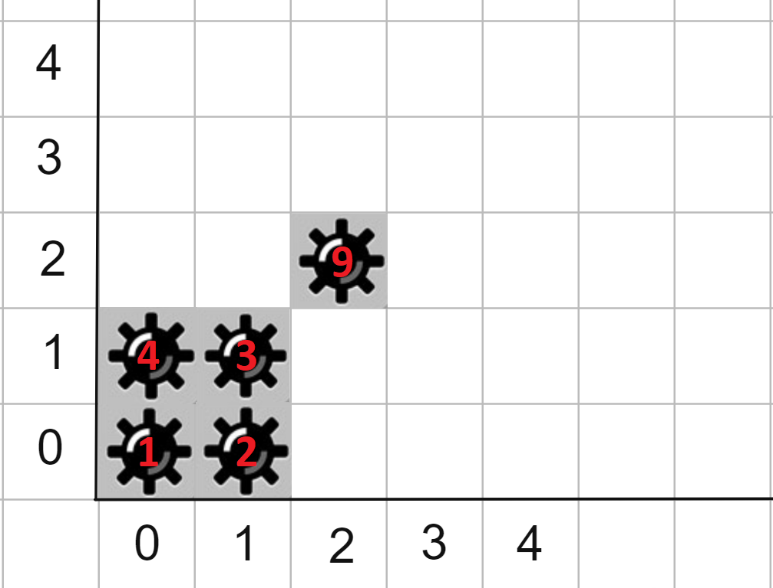Picture from examples

First example:

* 0 second: we explode a mine at the cell (2,2), it does not detonate any other mine since k=0.
* 1 second: we explode the mine at the cell (0,1), and the mine at the cell (0,0) explodes itself.
* 2 second: we explode the mine at the cell (1,1), and the mine at the cell (1,0) explodes itself.

Second example:

* 0 second: we explode a mine at the cell (2,2) we get:

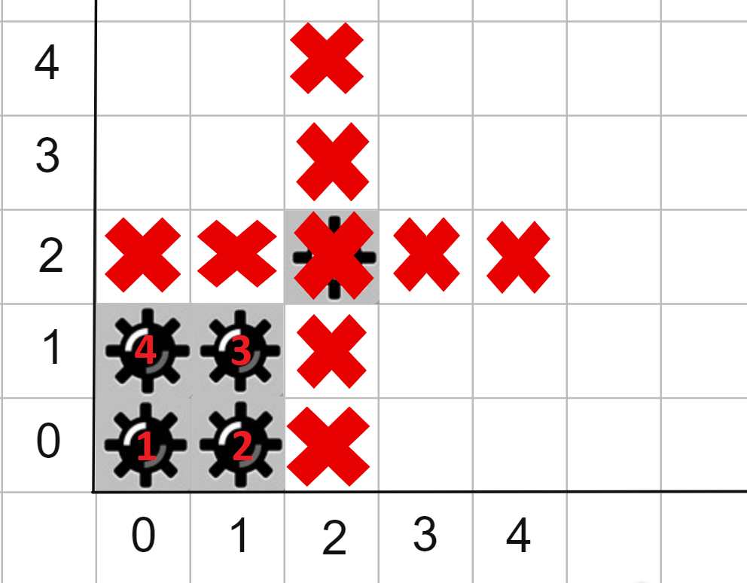

* 11 second: the mine at coordinate (0,0) explodes and since k=2 the explosion detonates mines at the cells (0,1) and (1,0), and their explosions detonate the mine at the cell (1,1) and there are no mines left on the field.